**Github:**

* Github.com/AnthonyYos/IoT
* github.com/aaackc
* github.com/s0720bae
* github.com/Alshaikh1abbas

**Video:**

Light sensor

<https://m.youtube.com/watch?v=VFet4nF8yuY>

UV sensor

<https://m.youtube.com/watch?v=m1BjQCFqr3I>

Dust sensor

<https://m.youtube.com/watch?v=U5Cwpnk1ybw>

Barometer sensor

<https://m.youtube.com/watch?v=_xlOQh04ntg>

Temperature and Humidity sensor

<https://m.youtube.com/watch?v=hvivq4QZbSg>

**ICP3 Full video linke:**

<https://github.com/Alshaikh1abbas/AAZDY/blob/master/ICP%203/full%20video%20ICP3.mp4>

**Introduction:**

The goal of ICP3 was to read weather humidity sensor, barometer sensor, UV sensor, dust sensor, and light sensor and transmit all readings to LCD and then through Wi-fi to thingspeak using the API writing key, to analyze given data into graphical information.

**Approaches/ Methods:**

* First we needed to correctly wire the LCD to the Arduino and display a message to confirm the connections were correct.
* Second we had all sensors connected to the circuit and then we tested them to make sure that they come with good reading on LCD.
* we had to create a connection via Wi-Fi between the Arduino and Thingspeak using an API key to get all sensors data graphically.
* We changed codes on Arduino for the sensors and also to integrate all of the modules together to transmit the data in different diagrams on Thingspeak.

**Workflow:**

First we connected both the LCD monitor and Wi-Fi to the circuit. Also, started to connect all sensors in order. After getting the correct connections, Wi-Fi was connected in wrong input. We had some difficulty integrating all modules to work in one code in order to display it on thingspeak .

**Circuit Diagram:**

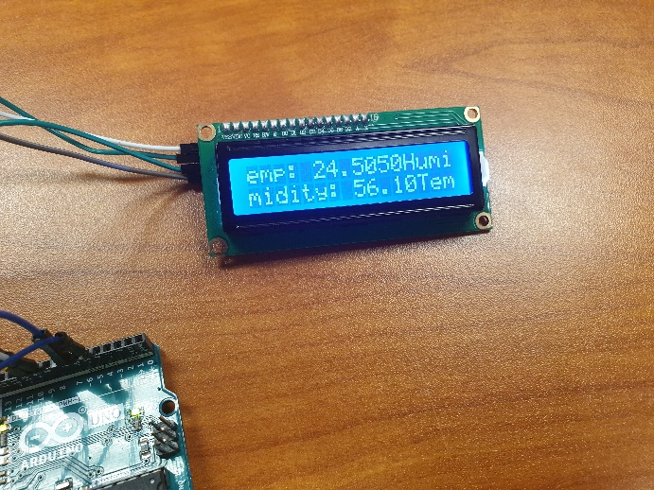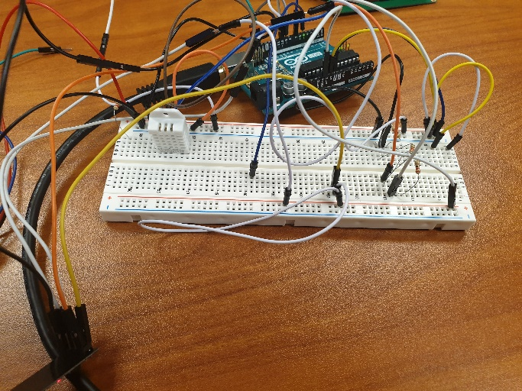

**Parameters:**

* LCD prints sensor results
* Wi-fi was changed to connect to a specific hotspot, and use a thingspeak write API key
* We adjusted the code to transmit results on thingspeak.
* Also adjusted the code to show same results on LCD monitor
* Added library code to enable barometer, and temperature sensors

**Evaluation & Discussion:**

There were some confusions on how display results on both lcd and thingspeak, after many tries, we were able to make it happen. Integrated all codes to work as one single code. Wi-Fi wired was wrong and we correct the wiring. Were able to show some results on thingspeak.

**Conclusion:**

We finally were able to do all 3 assignments’ parts as defining sensors and display them on LCD screen and thingspeak web page with phone app too. The hardest part was integrating all sensors in one code to work side by side in one code. The most important thing in this lecture that we learned how does each sensor work and how Arduino makes it easier with some code adjusting.